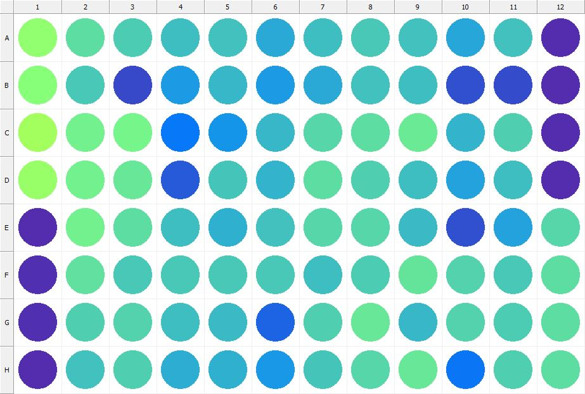

|  |
| --- |
| **Results for Tim_CTB(1) - channel 1 (RFU)** |

|  |  |  |  |  |  |  |  |  |  |  |  |  |
| --- | --- | --- | --- | --- | --- | --- | --- | --- | --- | --- | --- | --- |
|  | 01 | 02 | 03 | 04 | 05 | 06 | 07 | 08 | 09 | 10 | 11 | 12 |
| A | 183906 | 149349 | 137807 | 127437 | 129672 | 114700 | 128093 | 134102 | 130889 | 111192 | 129496 | 30253 |
| B | 176234 | 133382 | 49339 | 105354 | 122174 | 103618 | 113129 | 128913 | 127175 | 54344 | 50295 | 29217 |
| C | 195361 | 162240 | 164227 | 80096 | 99488 | 124011 | 143699 | 147740 | 158834 | 119540 | 139635 | 29824 |
| D | 188682 | 162084 | 155122 | 59377 | 131203 | 120440 | 148074 | 138756 | 127511 | 109458 | 128114 | 30791 |
| E | 30849 | 162330 | 147985 | 126510 | 117604 | 130769 | 143757 | 144072 | 125241 | 54168 | 109026 | 143809 |
| F | 32879 | 150574 | 135129 | 133536 | 134014 | 134534 | 128415 | 137687 | 153637 | 141895 | 133596 | 147392 |
| G | 31709 | 139492 | 140808 | 128447 | 125321 | 66770 | 138506 | 155741 | 123517 | 141374 | 135895 | 149236 |
| H | 30321 | 130221 | 139516 | 115043 | 118757 | 102791 | 131876 | 143955 | 156301 | 78583 | 139726 | 148938 |

|  |  |
| --- | --- |
| **Plate information** | |
|  | |
| **Plate** | 1 |
| **Repeat** | 1 |
| **Barcode** |  |
| **Measured height** | 14.78 |
| **Inside temperature at start** | 23.25 |
| **Inside temperature at end** | 23.25 |
| **Humidity at start** | 26.4 |
| **Humidity at end** | 26.4 |
| **Ambient temperature at start** | 22.95 |
| **Ambient temperature at end** | 22.86 |
| **Group** | 1 |
| **Label** | Tim_CTB(1) |
| **ScanX** | 0 |
| **ScanY** | 0 |
| **Measinfo** | De=1st Ex=Top Em=Top Wdw=N/A (14) |
| **Kinetics** | 0 |
| **Measurement date** | 12/12/2022 2:19:03 PM |
|  | |

|  |
| --- |
| **Background information** |
| Legend:  HDR1 - Plate  HDR2 - Label  HDR3 - Result  HDR4 - Signal  HDR5 - Flashes/Time  HDR6 - Meastime  HDR7 - MeasInfo |
| HDR1 HDR2 HDR3 HDR4 HDR5 HDR6 HDR7  1 Tim_CTB 0 1048 1 00:00:00.000 De=1st Ex=Top Em=Top Wdw=N/A (14) |
|  |

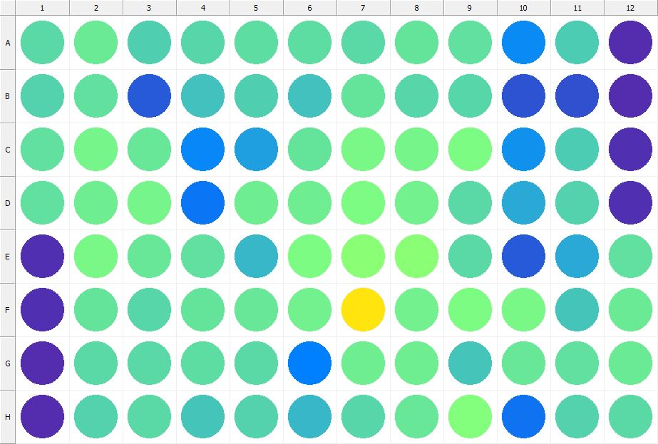

|  |
| --- |
| **Results for Tim_CTB(1) - channel 1 (RFU)** |

|  |  |  |  |  |  |  |  |  |  |  |  |  |
| --- | --- | --- | --- | --- | --- | --- | --- | --- | --- | --- | --- | --- |
|  | 01 | 02 | 03 | 04 | 05 | 06 | 07 | 08 | 09 | 10 | 11 | 12 |
| A | 147243 | 158716 | 139628 | 144025 | 147547 | 147549 | 145393 | 152340 | 151752 | 92860 | 136355 | 31016 |
| B | 142446 | 150405 | 59756 | 129502 | 138892 | 130171 | 153214 | 143697 | 143627 | 54557 | 53225 | 30262 |
| C | 151920 | 164854 | 156505 | 90406 | 107049 | 152183 | 167124 | 165748 | 169970 | 96491 | 137679 | 31361 |
| D | 151916 | 159960 | 163652 | 78251 | 159238 | 159853 | 169600 | 162080 | 145981 | 114663 | 142556 | 31784 |
| E | 31484 | 166688 | 155644 | 151386 | 123081 | 169743 | 178704 | 177919 | 145077 | 59205 | 113715 | 151582 |
| F | 31933 | 152634 | 143859 | 153848 | 156083 | 162946 | 277069 | 162626 | 170468 | 166816 | 132255 | 158043 |
| G | 31128 | 145512 | 145020 | 149513 | 145061 | 86165 | 159099 | 160919 | 131129 | 154556 | 151527 | 156890 |
| H | 30590 | 141790 | 146294 | 131712 | 140944 | 124005 | 143473 | 154548 | 173637 | 76378 | 141997 | 147269 |

|  |  |
| --- | --- |
| **Plate information** | |
|  | |
| **Plate** | 2 |
| **Repeat** | 1 |
| **Barcode** |  |
| **Measured height** | 14.78 |
| **Inside temperature at start** | 23.25 |
| **Inside temperature at end** | 23.25 |
| **Humidity at start** | 26.4 |
| **Humidity at end** | 26.4 |
| **Ambient temperature at start** | 22.95 |
| **Ambient temperature at end** | 22.86 |
| **Group** | 1 |
| **Label** | Tim_CTB(1) |
| **ScanX** | 0 |
| **ScanY** | 0 |
| **Measinfo** | De=1st Ex=Top Em=Top Wdw=N/A (14) |
| **Kinetics** | 0 |
| **Measurement date** | 12/12/2022 2:19:40 PM |
|  | |

|  |
| --- |
| **Background information** |
| Legend:  HDR1 - Plate  HDR2 - Label  HDR3 - Result  HDR4 - Signal  HDR5 - Flashes/Time  HDR6 - Meastime  HDR7 - MeasInfo |
| HDR1 HDR2 HDR3 HDR4 HDR5 HDR6 HDR7  2 Tim_CTB 0 1101 1 00:00:00.000 De=1st Ex=Top Em=Top Wdw=N/A (14) |
|  |

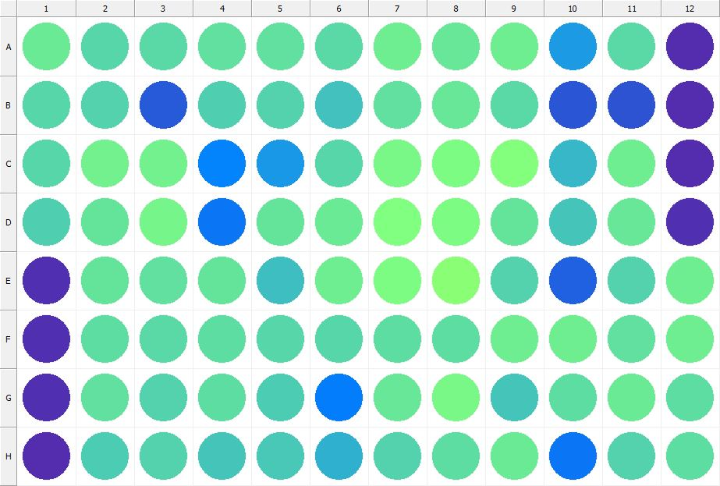

|  |
| --- |
| **Results for Tim_CTB(1) - channel 1 (RFU)** |

|  |  |  |  |  |  |  |  |  |  |  |  |  |
| --- | --- | --- | --- | --- | --- | --- | --- | --- | --- | --- | --- | --- |
|  | 01 | 02 | 03 | 04 | 05 | 06 | 07 | 08 | 09 | 10 | 11 | 12 |
| A | 156821 | 144674 | 145647 | 151644 | 150202 | 145096 | 159083 | 154863 | 159866 | 103624 | 144983 | 30440 |
| B | 143104 | 141671 | 60406 | 138526 | 142305 | 128998 | 151373 | 155172 | 146702 | 56847 | 56585 | 30406 |
| C | 143764 | 161330 | 162095 | 88112 | 102740 | 143355 | 167809 | 170408 | 174297 | 121927 | 159134 | 30974 |
| D | 138776 | 153414 | 164972 | 79885 | 154036 | 157935 | 171800 | 169389 | 152939 | 131270 | 154920 | 31780 |
| E | 31684 | 154006 | 150295 | 152461 | 126972 | 160336 | 169207 | 177749 | 141265 | 63969 | 140927 | 160093 |
| F | 31638 | 148896 | 145664 | 148467 | 143384 | 144077 | 147875 | 147576 | 160452 | 159524 | 150324 | 160734 |
| G | 31417 | 150928 | 140721 | 147603 | 137363 | 82547 | 155060 | 166054 | 132394 | 149544 | 157704 | 149509 |
| H | 29994 | 136933 | 142420 | 133297 | 135072 | 117384 | 141846 | 149224 | 157635 | 78148 | 142649 | 148805 |

|  |  |
| --- | --- |
| **Plate information** | |
|  | |
| **Plate** | 3 |
| **Repeat** | 1 |
| **Barcode** |  |
| **Measured height** | 14.78 |
| **Inside temperature at start** | 23.25 |
| **Inside temperature at end** | 23.25 |
| **Humidity at start** | 26.7 |
| **Humidity at end** | 26.6 |
| **Ambient temperature at start** | 22.95 |
| **Ambient temperature at end** | 23.05 |
| **Group** | 1 |
| **Label** | Tim_CTB(1) |
| **ScanX** | 0 |
| **ScanY** | 0 |
| **Measinfo** | De=1st Ex=Top Em=Top Wdw=N/A (14) |
| **Kinetics** | 0 |
| **Measurement date** | 12/12/2022 2:20:56 PM |
|  | |

|  |
| --- |
| **Background information** |
| Legend:  HDR1 - Plate  HDR2 - Label  HDR3 - Result  HDR4 - Signal  HDR5 - Flashes/Time  HDR6 - Meastime  HDR7 - MeasInfo |
| HDR1 HDR2 HDR3 HDR4 HDR5 HDR6 HDR7  3 Tim_CTB 0 1008 1 00:00:00.000 De=1st Ex=Top Em=Top Wdw=N/A (14) |
|  |

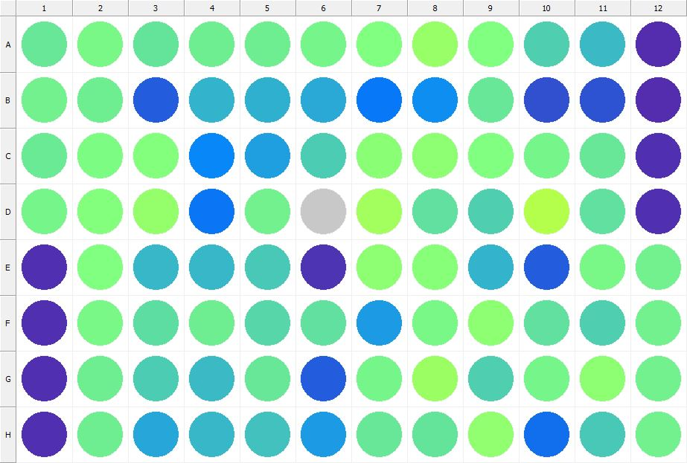

|  |
| --- |
| **Results for Tim_CTB(1) - channel 1 (RFU)** |

|  |  |  |  |  |  |  |  |  |  |  |  |  |
| --- | --- | --- | --- | --- | --- | --- | --- | --- | --- | --- | --- | --- |
|  | 01 | 02 | 03 | 04 | 05 | 06 | 07 | 08 | 09 | 10 | 11 | 12 |
| A | 154867 | 166522 | 151957 | 160217 | 160470 | 164532 | 170615 | 188763 | 170712 | 139052 | 124921 | 31299 |
| B | 161959 | 160553 | 62323 | 120662 | 118666 | 113211 | 80281 | 94213 | 155987 | 53302 | 56301 | 30856 |
| C | 158800 | 170378 | 173817 | 89965 | 105898 | 137593 | 179684 | 180061 | 172779 | 164660 | 156177 | 31465 |
| D | 164631 | 173365 | 185161 | 78277 | 162799 | 423007 | 193820 | 151752 | 139104 | 206089 | 150104 | 33026 |
| E | 32475 | 172110 | 122757 | 122569 | 133656 | 34153 | 180699 | 175771 | 120590 | 62605 | 166442 | 161345 |
| F | 32830 | 167321 | 147692 | 159572 | 143934 | 150564 | 103352 | 166125 | 182057 | 150092 | 140060 | 162847 |
| G | 31341 | 160238 | 137349 | 125457 | 154844 | 61790 | 165131 | 190016 | 139110 | 163713 | 181153 | 161971 |
| H | 31679 | 159119 | 112189 | 122992 | 129347 | 104606 | 155663 | 153582 | 182917 | 74233 | 133438 | 162889 |

|  |  |
| --- | --- |
| **Plate information** | |
|  | |
| **Plate** | 4 |
| **Repeat** | 1 |
| **Barcode** |  |
| **Measured height** | 14.78 |
| **Inside temperature at start** | 23.25 |
| **Inside temperature at end** | 23.25 |
| **Humidity at start** | 26.2 |
| **Humidity at end** | 26.2 |
| **Ambient temperature at start** | 23.15 |
| **Ambient temperature at end** | 23.15 |
| **Group** | 1 |
| **Label** | Tim_CTB(1) |
| **ScanX** | 0 |
| **ScanY** | 0 |
| **Measinfo** | De=1st Ex=Top Em=Top Wdw=N/A (14) |
| **Kinetics** | 0 |
| **Measurement date** | 12/12/2022 2:21:39 PM |
|  | |

|  |
| --- |
| **Background information** |
| Legend:  HDR1 - Plate  HDR2 - Label  HDR3 - Result  HDR4 - Signal  HDR5 - Flashes/Time  HDR6 - Meastime  HDR7 - MeasInfo |
| HDR1 HDR2 HDR3 HDR4 HDR5 HDR6 HDR7  4 Tim_CTB 0 1044 1 00:00:00.000 De=1st Ex=Top Em=Top Wdw=N/A (14) |
|  |

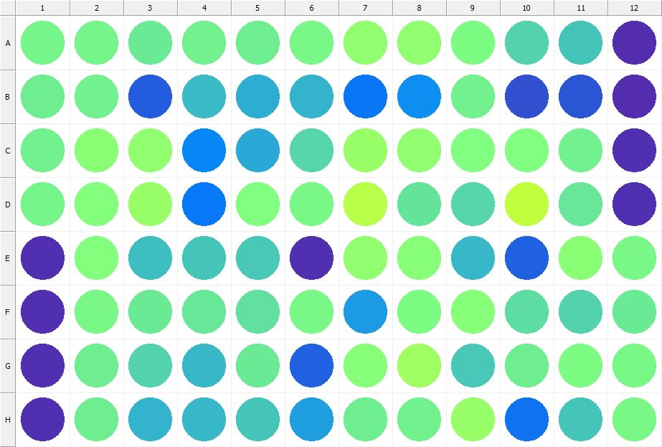

|  |
| --- |
| **Results for Tim_CTB(1) - channel 1 (RFU)** |

|  |  |  |  |  |  |  |  |  |  |  |  |  |
| --- | --- | --- | --- | --- | --- | --- | --- | --- | --- | --- | --- | --- |
|  | 01 | 02 | 03 | 04 | 05 | 06 | 07 | 08 | 09 | 10 | 11 | 12 |
| A | 164331 | 164090 | 156747 | 162629 | 160775 | 167001 | 183191 | 183967 | 169312 | 142548 | 132182 | 30884 |
| B | 160849 | 161228 | 63611 | 126003 | 115974 | 121015 | 78243 | 95863 | 163266 | 53817 | 57156 | 30802 |
| C | 162784 | 177954 | 183118 | 89919 | 112886 | 144751 | 188783 | 182532 | 171152 | 172597 | 162029 | 31490 |
| D | 164252 | 172924 | 187847 | 80166 | 171507 | 167124 | 208369 | 153357 | 144666 | 214832 | 154782 | 31655 |
| E | 32237 | 174544 | 126699 | 131754 | 133860 | 31776 | 183734 | 177332 | 123295 | 63940 | 178737 | 167103 |
| F | 31921 | 166235 | 157630 | 156556 | 151032 | 166411 | 105260 | 169772 | 177112 | 148568 | 141832 | 158352 |
| G | 32033 | 160768 | 141654 | 123967 | 158838 | 63995 | 176224 | 192340 | 135022 | 160120 | 169676 | 166162 |
| H | 32591 | 160696 | 120474 | 123120 | 131679 | 107806 | 161154 | 162779 | 186903 | 77419 | 132848 | 166185 |

|  |  |
| --- | --- |
| **Plate information** | |
|  | |
| **Plate** | 5 |
| **Repeat** | 1 |
| **Barcode** |  |
| **Measured height** | 14.78 |
| **Inside temperature at start** | 23.25 |
| **Inside temperature at end** | 23.25 |
| **Humidity at start** | 26.2 |
| **Humidity at end** | 26.2 |
| **Ambient temperature at start** | 23.15 |
| **Ambient temperature at end** | 23.05 |
| **Group** | 1 |
| **Label** | Tim_CTB(1) |
| **ScanX** | 0 |
| **ScanY** | 0 |
| **Measinfo** | De=1st Ex=Top Em=Top Wdw=N/A (14) |
| **Kinetics** | 0 |
| **Measurement date** | 12/12/2022 2:22:18 PM |
|  | |

|  |
| --- |
| **Background information** |
| Legend:  HDR1 - Plate  HDR2 - Label  HDR3 - Result  HDR4 - Signal  HDR5 - Flashes/Time  HDR6 - Meastime  HDR7 - MeasInfo |
| HDR1 HDR2 HDR3 HDR4 HDR5 HDR6 HDR7  5 Tim_CTB 0 994 1 00:00:00.000 De=1st Ex=Top Em=Top Wdw=N/A (14) |
|  |

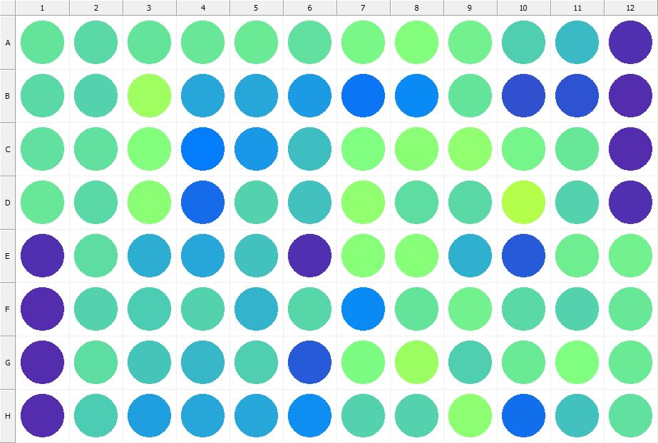

|  |
| --- |
| **Results for Tim_CTB(1) - channel 1 (RFU)** |

|  |  |  |  |  |  |  |  |  |  |  |  |  |
| --- | --- | --- | --- | --- | --- | --- | --- | --- | --- | --- | --- | --- |
|  | 01 | 02 | 03 | 04 | 05 | 06 | 07 | 08 | 09 | 10 | 11 | 12 |
| A | 153664 | 146345 | 152126 | 154788 | 158708 | 151456 | 167083 | 174364 | 163430 | 138665 | 125252 | 31878 |
| B | 146669 | 141121 | 192078 | 112423 | 111588 | 103904 | 79242 | 91834 | 154200 | 54103 | 56136 | 30515 |
| C | 151752 | 151782 | 173842 | 83423 | 102523 | 126726 | 170980 | 177526 | 182455 | 165604 | 154713 | 31149 |
| D | 155500 | 146454 | 178829 | 72290 | 141780 | 130502 | 182145 | 147562 | 146305 | 207530 | 140701 | 32330 |
| E | 32786 | 148534 | 115723 | 110588 | 130845 | 31592 | 176179 | 176155 | 117918 | 60148 | 158934 | 162075 |
| F | 30631 | 141423 | 135924 | 141114 | 121599 | 144616 | 92694 | 153003 | 163211 | 145814 | 140661 | 154800 |
| G | 31235 | 148962 | 131279 | 123206 | 138809 | 60925 | 170327 | 191183 | 138967 | 158781 | 171459 | 158798 |
| H | 30849 | 137845 | 106936 | 112365 | 111063 | 94694 | 140373 | 141271 | 181071 | 73990 | 129600 | 150093 |

|  |  |
| --- | --- |
| **Plate information** | |
|  | |
| **Plate** | 6 |
| **Repeat** | 1 |
| **Barcode** |  |
| **Measured height** | 14.78 |
| **Inside temperature at start** | 23.34 |
| **Inside temperature at end** | 23.34 |
| **Humidity at start** | 26.4 |
| **Humidity at end** | 26.6 |
| **Ambient temperature at start** | 22.86 |
| **Ambient temperature at end** | 22.95 |
| **Group** | 1 |
| **Label** | Tim_CTB(1) |
| **ScanX** | 0 |
| **ScanY** | 0 |
| **Measinfo** | De=1st Ex=Top Em=Top Wdw=N/A (14) |
| **Kinetics** | 0 |
| **Measurement date** | 12/12/2022 2:22:56 PM |
|  | |

|  |
| --- |
| **Background information** |
| Legend:  HDR1 - Plate  HDR2 - Label  HDR3 - Result  HDR4 - Signal  HDR5 - Flashes/Time  HDR6 - Meastime  HDR7 - MeasInfo |
| HDR1 HDR2 HDR3 HDR4 HDR5 HDR6 HDR7  6 Tim_CTB 0 1100 1 00:00:00.000 De=1st Ex=Top Em=Top Wdw=N/A (14) |
|  |

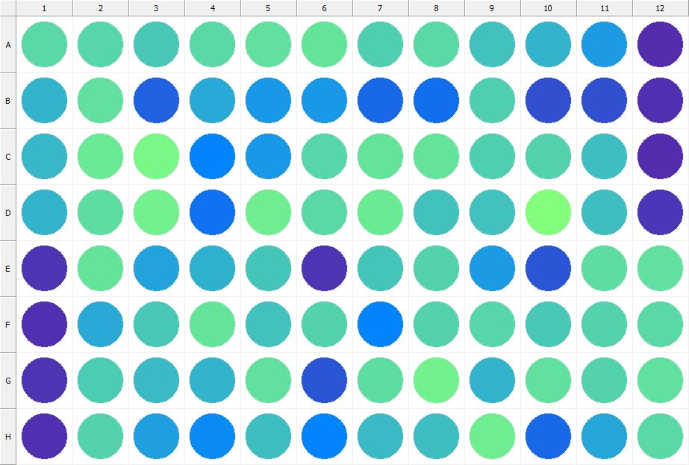

|  |
| --- |
| **Results for Tim_CTB(1) - channel 1 (RFU)** |

|  |  |  |  |  |  |  |  |  |  |  |  |  |
| --- | --- | --- | --- | --- | --- | --- | --- | --- | --- | --- | --- | --- |
|  | 01 | 02 | 03 | 04 | 05 | 06 | 07 | 08 | 09 | 10 | 11 | 12 |
| A | 146555 | 144829 | 134904 | 146962 | 150576 | 153791 | 139636 | 145921 | 131014 | 121084 | 104353 | 31058 |
| B | 120865 | 150125 | 63869 | 114383 | 103004 | 101865 | 68569 | 73892 | 138346 | 52967 | 53023 | 31651 |
| C | 122706 | 158297 | 167332 | 88227 | 102789 | 143210 | 153639 | 152585 | 139050 | 141602 | 127143 | 31056 |
| D | 119952 | 149392 | 163376 | 76797 | 160665 | 146296 | 158492 | 129186 | 130669 | 175100 | 128030 | 36517 |
| E | 34747 | 153460 | 108203 | 117183 | 131160 | 35870 | 132794 | 141072 | 105368 | 59125 | 148346 | 149718 |
| F | 33248 | 114651 | 135100 | 153222 | 128826 | 140729 | 87602 | 141782 | 144342 | 135376 | 141187 | 145507 |
| G | 33885 | 136545 | 125784 | 119988 | 150853 | 57312 | 149261 | 161528 | 120451 | 150403 | 141479 | 150750 |
| H | 33051 | 142557 | 106364 | 91922 | 127157 | 88755 | 126386 | 128289 | 160699 | 68651 | 112242 | 145304 |

|  |  |
| --- | --- |
| **Plate information** | |
|  | |
| **Plate** | 7 |
| **Repeat** | 1 |
| **Barcode** |  |
| **Measured height** | 14.78 |
| **Inside temperature at start** | 23.34 |
| **Inside temperature at end** | 23.34 |
| **Humidity at start** | 26.2 |
| **Humidity at end** | 26.2 |
| **Ambient temperature at start** | 23.05 |
| **Ambient temperature at end** | 23.05 |
| **Group** | 1 |
| **Label** | Tim_CTB(1) |
| **ScanX** | 0 |
| **ScanY** | 0 |
| **Measinfo** | De=1st Ex=Top Em=Top Wdw=N/A (14) |
| **Kinetics** | 0 |
| **Measurement date** | 12/12/2022 2:23:33 PM |
|  | |

|  |
| --- |
| **Background information** |
| Legend:  HDR1 - Plate  HDR2 - Label  HDR3 - Result  HDR4 - Signal  HDR5 - Flashes/Time  HDR6 - Meastime  HDR7 - MeasInfo |
| HDR1 HDR2 HDR3 HDR4 HDR5 HDR6 HDR7  7 Tim_CTB 0 1046 1 00:00:00.000 De=1st Ex=Top Em=Top Wdw=N/A (14) |
|  |

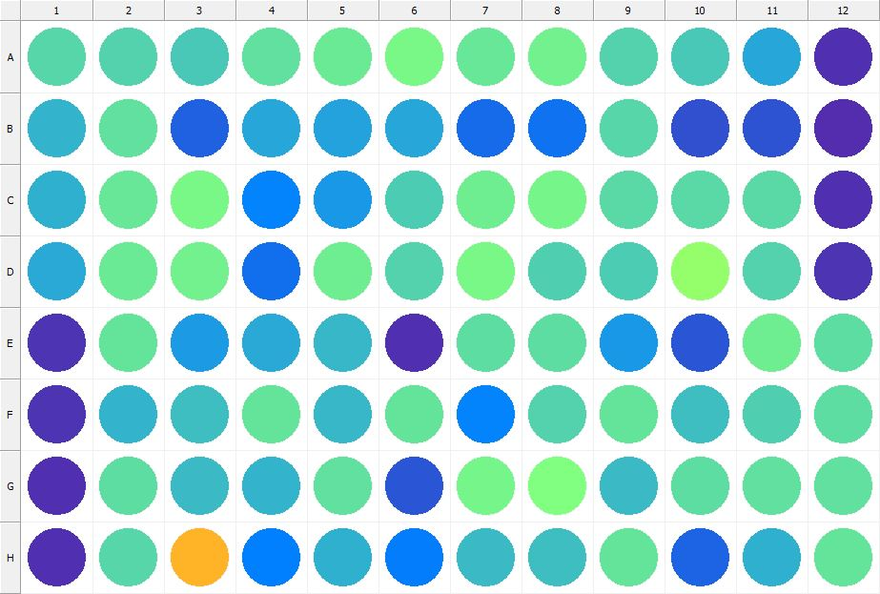

|  |
| --- |
| **Results for Tim_CTB(1) - channel 1 (RFU)** |

|  |  |  |  |  |  |  |  |  |  |  |  |  |
| --- | --- | --- | --- | --- | --- | --- | --- | --- | --- | --- | --- | --- |
|  | 01 | 02 | 03 | 04 | 05 | 06 | 07 | 08 | 09 | 10 | 11 | 12 |
| A | 144284 | 140533 | 134581 | 151622 | 157531 | 167027 | 156229 | 162165 | 141219 | 134220 | 111377 | 31507 |
| B | 120603 | 149802 | 65271 | 112169 | 108234 | 112264 | 71684 | 75784 | 144530 | 52784 | 55983 | 30894 |
| C | 117261 | 154463 | 167637 | 88681 | 100971 | 136912 | 160308 | 165263 | 146975 | 147155 | 145296 | 31473 |
| D | 114278 | 157945 | 162836 | 74470 | 160252 | 141881 | 167272 | 138569 | 136234 | 185620 | 140744 | 34509 |
| E | 34785 | 153064 | 104404 | 113972 | 123063 | 32203 | 147844 | 147383 | 101786 | 58499 | 159557 | 149220 |
| F | 34009 | 121511 | 128210 | 153630 | 122753 | 153603 | 88441 | 142078 | 152918 | 126427 | 138744 | 148344 |
| G | 33011 | 148798 | 125570 | 120615 | 151729 | 58840 | 164090 | 171600 | 124891 | 149522 | 149982 | 150865 |
| H | 33350 | 144208 | 308847 | 86529 | 119356 | 84572 | 126089 | 126962 | 154024 | 66749 | 118582 | 152141 |

|  |  |
| --- | --- |
| **Plate information** | |
|  | |
| **Plate** | 8 |
| **Repeat** | 1 |
| **Barcode** |  |
| **Measured height** | 14.78 |
| **Inside temperature at start** | 23.34 |
| **Inside temperature at end** | 23.34 |
| **Humidity at start** | 26.1 |
| **Humidity at end** | 26.1 |
| **Ambient temperature at start** | 23.15 |
| **Ambient temperature at end** | 23.05 |
| **Group** | 1 |
| **Label** | Tim_CTB(1) |
| **ScanX** | 0 |
| **ScanY** | 0 |
| **Measinfo** | De=1st Ex=Top Em=Top Wdw=N/A (14) |
| **Kinetics** | 0 |
| **Measurement date** | 12/12/2022 2:24:12 PM |
|  | |

|  |
| --- |
| **Background information** |
| Legend:  HDR1 - Plate  HDR2 - Label  HDR3 - Result  HDR4 - Signal  HDR5 - Flashes/Time  HDR6 - Meastime  HDR7 - MeasInfo |
| HDR1 HDR2 HDR3 HDR4 HDR5 HDR6 HDR7  8 Tim_CTB 0 1074 1 00:00:00.000 De=1st Ex=Top Em=Top Wdw=N/A (14) |
|  |

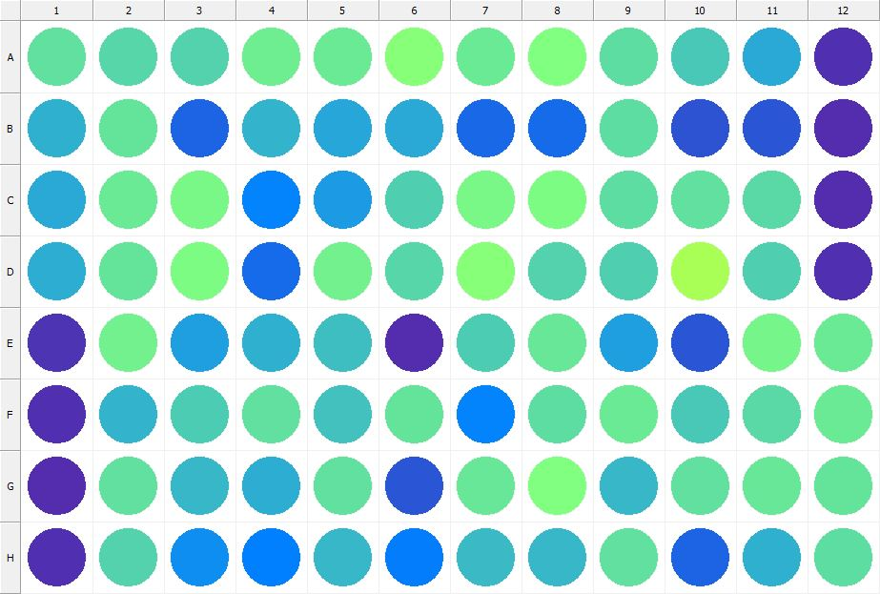

|  |
| --- |
| **Results for Tim_CTB(1) - channel 1 (RFU)** |

|  |  |  |  |  |  |  |  |  |  |  |  |  |
| --- | --- | --- | --- | --- | --- | --- | --- | --- | --- | --- | --- | --- |
|  | 01 | 02 | 03 | 04 | 05 | 06 | 07 | 08 | 09 | 10 | 11 | 12 |
| A | 150144 | 144525 | 141727 | 160223 | 158511 | 176720 | 158033 | 170994 | 148202 | 134949 | 114031 | 31321 |
| B | 118483 | 152957 | 67157 | 119698 | 110252 | 112728 | 68594 | 71986 | 148030 | 55662 | 57631 | 30662 |
| C | 114064 | 157240 | 167721 | 89033 | 104948 | 138381 | 167325 | 169612 | 148935 | 150596 | 146822 | 30871 |
| D | 116518 | 152438 | 168998 | 72881 | 163150 | 143594 | 177003 | 142443 | 138344 | 200542 | 139681 | 33586 |
| E | 34417 | 161443 | 107305 | 117239 | 126790 | 30671 | 137361 | 155288 | 107817 | 58507 | 164235 | 157909 |
| F | 32028 | 121119 | 135875 | 151203 | 129202 | 152027 | 87861 | 147860 | 156732 | 134179 | 147044 | 158598 |
| G | 31194 | 151472 | 122168 | 116288 | 151929 | 58435 | 154330 | 171072 | 123312 | 150435 | 156295 | 153904 |
| H | 31824 | 141686 | 94349 | 86098 | 123288 | 84500 | 126138 | 122291 | 150333 | 67082 | 119119 | 148570 |

|  |  |
| --- | --- |
| **Plate information** | |
|  | |
| **Plate** | 9 |
| **Repeat** | 1 |
| **Barcode** |  |
| **Measured height** | 14.78 |
| **Inside temperature at start** | 23.34 |
| **Inside temperature at end** | 23.34 |
| **Humidity at start** | 26.1 |
| **Humidity at end** | 26.2 |
| **Ambient temperature at start** | 23.25 |
| **Ambient temperature at end** | 23.15 |
| **Group** | 1 |
| **Label** | Tim_CTB(1) |
| **ScanX** | 0 |
| **ScanY** | 0 |
| **Measinfo** | De=1st Ex=Top Em=Top Wdw=N/A (14) |
| **Kinetics** | 0 |
| **Measurement date** | 12/12/2022 2:24:52 PM |
|  | |

|  |
| --- |
| **Background information** |
| Legend:  HDR1 - Plate  HDR2 - Label  HDR3 - Result  HDR4 - Signal  HDR5 - Flashes/Time  HDR6 - Meastime  HDR7 - MeasInfo |
| HDR1 HDR2 HDR3 HDR4 HDR5 HDR6 HDR7  9 Tim_CTB 0 1148 1 00:00:00.000 De=1st Ex=Top Em=Top Wdw=N/A (14) |
|  |

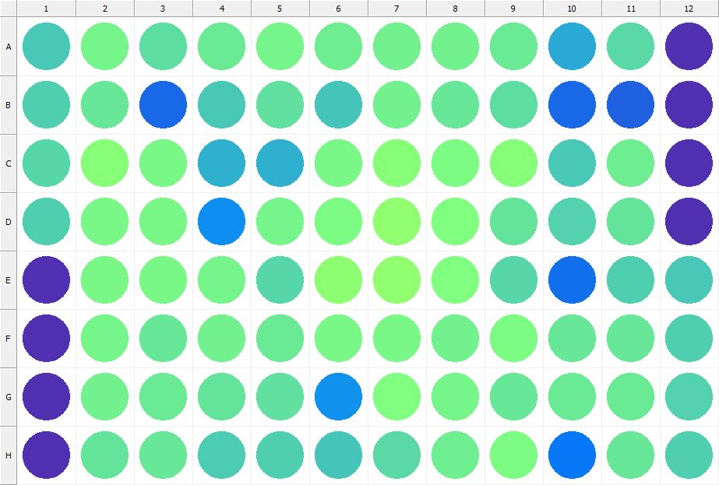

|  |
| --- |
| **Results for Tim_CTB(1) - channel 1 (RFU)** |

|  |  |  |  |  |  |  |  |  |  |  |  |  |
| --- | --- | --- | --- | --- | --- | --- | --- | --- | --- | --- | --- | --- |
|  | 01 | 02 | 03 | 04 | 05 | 06 | 07 | 08 | 09 | 10 | 11 | 12 |
| A | 134616 | 165068 | 148761 | 158397 | 164675 | 159729 | 161230 | 161521 | 157457 | 113963 | 147081 | 32642 |
| B | 138087 | 155016 | 70033 | 133733 | 151142 | 132041 | 163295 | 156482 | 147483 | 69568 | 64055 | 31726 |
| C | 143675 | 176096 | 167782 | 118338 | 119217 | 166496 | 175947 | 169707 | 175338 | 134125 | 160052 | 31829 |
| D | 139232 | 167611 | 166972 | 94007 | 164714 | 170471 | 183435 | 171181 | 152470 | 142093 | 152266 | 32756 |
| E | 33452 | 167280 | 167316 | 164950 | 144260 | 180563 | 182430 | 172055 | 144102 | 74978 | 140207 | 134140 |
| F | 32626 | 164534 | 154480 | 161944 | 156924 | 167336 | 166232 | 162240 | 170130 | 154563 | 156269 | 139310 |
| G | 32352 | 161586 | 157460 | 152913 | 149940 | 97456 | 171498 | 164027 | 155670 | 156872 | 157651 | 141838 |
| H | 33119 | 153718 | 155414 | 136669 | 138747 | 132606 | 145981 | 160672 | 169855 | 80862 | 155263 | 140008 |

|  |  |
| --- | --- |
| **Plate information** | |
|  | |
| **Plate** | 10 |
| **Repeat** | 1 |
| **Barcode** |  |
| **Measured height** | 14.78 |
| **Inside temperature at start** | 23.25 |
| **Inside temperature at end** | 23.25 |
| **Humidity at start** | 26.6 |
| **Humidity at end** | 26.7 |
| **Ambient temperature at start** | 22.57 |
| **Ambient temperature at end** | 22.57 |
| **Group** | 1 |
| **Label** | Tim_CTB(1) |
| **ScanX** | 0 |
| **ScanY** | 0 |
| **Measinfo** | De=1st Ex=Top Em=Top Wdw=N/A (14) |
| **Kinetics** | 0 |
| **Measurement date** | 12/12/2022 2:27:09 PM |
|  | |

|  |
| --- |
| **Background information** |
| Legend:  HDR1 - Plate  HDR2 - Label  HDR3 - Result  HDR4 - Signal  HDR5 - Flashes/Time  HDR6 - Meastime  HDR7 - MeasInfo |
| HDR1 HDR2 HDR3 HDR4 HDR5 HDR6 HDR7  10 Tim_CTB 0 1107 1 00:00:00.000 De=1st Ex=Top Em=Top Wdw=N/A (14) |
|  |

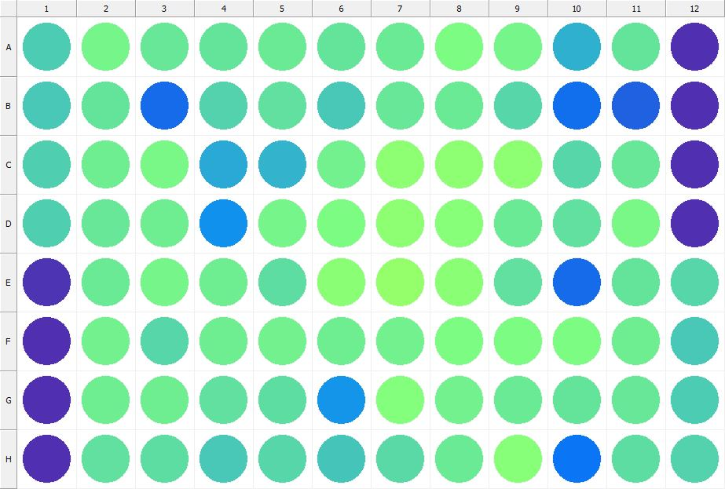

|  |
| --- |
| **Results for Tim_CTB(1) - channel 1 (RFU)** |

|  |  |  |  |  |  |  |  |  |  |  |  |  |
| --- | --- | --- | --- | --- | --- | --- | --- | --- | --- | --- | --- | --- |
|  | 01 | 02 | 03 | 04 | 05 | 06 | 07 | 08 | 09 | 10 | 11 | 12 |
| A | 136813 | 163750 | 154405 | 153587 | 157052 | 153364 | 157287 | 170100 | 164254 | 119441 | 152293 | 32541 |
| B | 134549 | 153762 | 72767 | 141388 | 149944 | 134374 | 156016 | 157907 | 143533 | 73198 | 64225 | 31802 |
| C | 139285 | 159999 | 166867 | 114767 | 120286 | 163079 | 180317 | 180650 | 181705 | 143836 | 156334 | 31709 |
| D | 139447 | 156243 | 160024 | 96578 | 165174 | 168369 | 180314 | 177335 | 157836 | 151183 | 165995 | 32871 |
| E | 34937 | 157592 | 163815 | 159150 | 148054 | 178653 | 185390 | 178877 | 151154 | 71623 | 151931 | 142952 |
| F | 33550 | 162931 | 142761 | 160519 | 163039 | 159666 | 162699 | 169784 | 169495 | 168328 | 159011 | 135259 |
| G | 33592 | 159590 | 159686 | 151929 | 148222 | 100155 | 174454 | 162607 | 158567 | 152732 | 156262 | 135931 |
| H | 32070 | 151929 | 149356 | 133862 | 143203 | 132543 | 146971 | 158801 | 176411 | 77831 | 149435 | 142327 |

|  |  |
| --- | --- |
| **Plate information** | |
|  | |
| **Plate** | 11 |
| **Repeat** | 1 |
| **Barcode** |  |
| **Measured height** | 14.78 |
| **Inside temperature at start** | 23.25 |
| **Inside temperature at end** | 23.34 |
| **Humidity at start** | 26.7 |
| **Humidity at end** | 26.7 |
| **Ambient temperature at start** | 22.66 |
| **Ambient temperature at end** | 22.86 |
| **Group** | 1 |
| **Label** | Tim_CTB(1) |
| **ScanX** | 0 |
| **ScanY** | 0 |
| **Measinfo** | De=1st Ex=Top Em=Top Wdw=N/A (14) |
| **Kinetics** | 0 |
| **Measurement date** | 12/12/2022 2:27:49 PM |
|  | |

|  |
| --- |
| **Background information** |
| Legend:  HDR1 - Plate  HDR2 - Label  HDR3 - Result  HDR4 - Signal  HDR5 - Flashes/Time  HDR6 - Meastime  HDR7 - MeasInfo |
| HDR1 HDR2 HDR3 HDR4 HDR5 HDR6 HDR7  11 Tim_CTB 0 1141 1 00:00:00.000 De=1st Ex=Top Em=Top Wdw=N/A (14) |
|  |

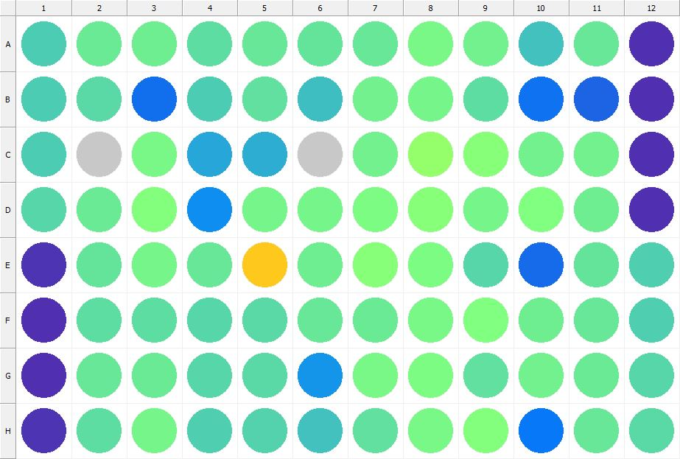

|  |
| --- |
| **Results for Tim_CTB(1) - channel 1 (RFU)** |

|  |  |  |  |  |  |  |  |  |  |  |  |  |
| --- | --- | --- | --- | --- | --- | --- | --- | --- | --- | --- | --- | --- |
|  | 01 | 02 | 03 | 04 | 05 | 06 | 07 | 08 | 09 | 10 | 11 | 12 |
| A | 137643 | 158512 | 160941 | 147498 | 155191 | 152285 | 155832 | 165919 | 162917 | 128790 | 156236 | 32630 |
| B | 137741 | 146444 | 73456 | 137632 | 150478 | 126922 | 162759 | 164950 | 149173 | 76210 | 66978 | 32227 |
| C | 136752 | 424062 | 165878 | 110183 | 114894 | 424582 | 163051 | 185662 | 176310 | 163047 | 162661 | 33393 |
| D | 144165 | 156697 | 172999 | 94100 | 164783 | 164224 | 168553 | 175609 | 163737 | 172743 | 160782 | 33615 |
| E | 34010 | 153234 | 163946 | 156397 | 293675 | 161104 | 176462 | 169750 | 143749 | 72053 | 152413 | 139791 |
| F | 33348 | 149538 | 149314 | 144653 | 145981 | 156090 | 157699 | 168123 | 170931 | 159553 | 156203 | 138832 |
| G | 33296 | 155958 | 157470 | 144518 | 146932 | 98844 | 166436 | 169069 | 151150 | 162514 | 158688 | 144256 |
| H | 33809 | 147566 | 165081 | 138576 | 141553 | 129456 | 150435 | 166556 | 175058 | 80955 | 155711 | 146045 |

|  |  |
| --- | --- |
| **Plate information** | |
|  | |
| **Plate** | 12 |
| **Repeat** | 1 |
| **Barcode** |  |
| **Measured height** | 14.78 |
| **Inside temperature at start** | 23.34 |
| **Inside temperature at end** | 23.34 |
| **Humidity at start** | 26.4 |
| **Humidity at end** | 26.6 |
| **Ambient temperature at start** | 22.95 |
| **Ambient temperature at end** | 22.95 |
| **Group** | 1 |
| **Label** | Tim_CTB(1) |
| **ScanX** | 0 |
| **ScanY** | 0 |
| **Measinfo** | De=1st Ex=Top Em=Top Wdw=N/A (14) |
| **Kinetics** | 0 |
| **Measurement date** | 12/12/2022 2:28:31 PM |
|  | |

|  |
| --- |
| **Background information** |
| Legend:  HDR1 - Plate  HDR2 - Label  HDR3 - Result  HDR4 - Signal  HDR5 - Flashes/Time  HDR6 - Meastime  HDR7 - MeasInfo |
| HDR1 HDR2 HDR3 HDR4 HDR5 HDR6 HDR7  12 Tim_CTB 0 1073 1 00:00:00.000 De=1st Ex=Top Em=Top Wdw=N/A (14) |
|  |

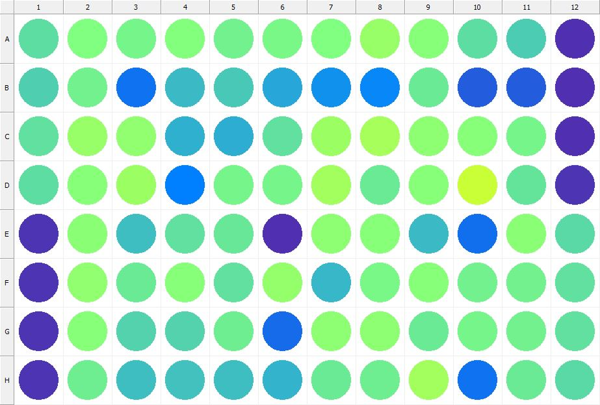

|  |
| --- |
| **Results for Tim_CTB(1) - channel 1 (RFU)** |

|  |  |  |  |  |  |  |  |  |  |  |  |  |
| --- | --- | --- | --- | --- | --- | --- | --- | --- | --- | --- | --- | --- |
|  | 01 | 02 | 03 | 04 | 05 | 06 | 07 | 08 | 09 | 10 | 11 | 12 |
| A | 147821 | 171421 | 164228 | 174247 | 161620 | 167099 | 170818 | 187436 | 176321 | 147817 | 135948 | 32414 |
| B | 139551 | 163431 | 77158 | 124177 | 135493 | 112420 | 96954 | 91464 | 157061 | 62287 | 61702 | 32228 |
| C | 151588 | 187847 | 182994 | 118383 | 116730 | 150105 | 191050 | 196213 | 181127 | 175586 | 165172 | 33137 |
| D | 148476 | 177362 | 189291 | 86877 | 165293 | 163702 | 195645 | 157948 | 176363 | 221494 | 154122 | 33748 |
| E | 35387 | 178310 | 127475 | 150723 | 156246 | 31326 | 180415 | 176979 | 126099 | 73242 | 179055 | 146833 |
| F | 34514 | 182209 | 157635 | 175132 | 151262 | 185897 | 122138 | 167915 | 175296 | 161278 | 163222 | 151622 |
| G | 33692 | 175919 | 140673 | 140501 | 159420 | 72599 | 180805 | 181696 | 157212 | 165131 | 162815 | 150538 |
| H | 33839 | 159791 | 127525 | 130071 | 127087 | 120718 | 156668 | 159906 | 195001 | 77052 | 158542 | 146194 |

|  |  |
| --- | --- |
| **Plate information** | |
|  | |
| **Plate** | 13 |
| **Repeat** | 1 |
| **Barcode** |  |
| **Measured height** | 14.78 |
| **Inside temperature at start** | 23.34 |
| **Inside temperature at end** | 23.36 |
| **Humidity at start** | 26.7 |
| **Humidity at end** | 26.7 |
| **Ambient temperature at start** | 22.76 |
| **Ambient temperature at end** | 22.78 |
| **Group** | 1 |
| **Label** | Tim_CTB(1) |
| **ScanX** | 0 |
| **ScanY** | 0 |
| **Measinfo** | De=1st Ex=Top Em=Top Wdw=N/A (14) |
| **Kinetics** | 0 |
| **Measurement date** | 12/12/2022 2:29:20 PM |
|  | |

|  |
| --- |
| **Background information** |
| Legend:  HDR1 - Plate  HDR2 - Label  HDR3 - Result  HDR4 - Signal  HDR5 - Flashes/Time  HDR6 - Meastime  HDR7 - MeasInfo |
| HDR1 HDR2 HDR3 HDR4 HDR5 HDR6 HDR7  13 Tim_CTB 0 1027 1 00:00:00.000 De=1st Ex=Top Em=Top Wdw=N/A (14) |
|  |

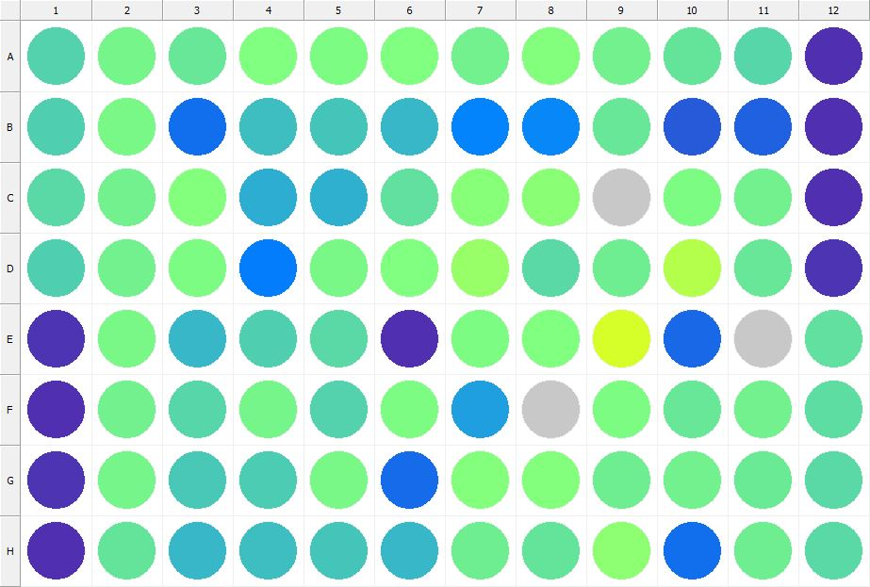

|  |
| --- |
| **Results for Tim_CTB(1) - channel 1 (RFU)** |

|  |  |  |  |  |  |  |  |  |  |  |  |  |
| --- | --- | --- | --- | --- | --- | --- | --- | --- | --- | --- | --- | --- |
|  | 01 | 02 | 03 | 04 | 05 | 06 | 07 | 08 | 09 | 10 | 11 | 12 |
| A | 142358 | 165388 | 156114 | 171887 | 169272 | 171159 | 162818 | 174109 | 161645 | 152457 | 144799 | 32756 |
| B | 138970 | 165974 | 73174 | 128669 | 133159 | 122831 | 87940 | 91014 | 156247 | 60988 | 64129 | 32253 |
| C | 145291 | 161358 | 173222 | 116671 | 117366 | 151361 | 177239 | 178749 | 432429 | 168727 | 161868 | 32553 |
| D | 140139 | 162782 | 169208 | 84252 | 167026 | 171639 | 188330 | 145609 | 159908 | 206508 | 155493 | 34146 |
| E | 34448 | 166532 | 122938 | 138342 | 145375 | 32136 | 169777 | 172338 | 230305 | 70442 | 434521 | 151274 |
| F | 33000 | 161876 | 144526 | 163800 | 140714 | 170114 | 107101 | 429814 | 170231 | 155739 | 163471 | 148767 |
| G | 34236 | 164088 | 135157 | 136174 | 166957 | 71297 | 174011 | 173277 | 160663 | 161752 | 158307 | 146783 |
| H | 32523 | 152663 | 123898 | 127173 | 132723 | 122459 | 158901 | 152301 | 180737 | 75281 | 160343 | 146521 |

|  |  |
| --- | --- |
| **Plate information** | |
|  | |
| **Plate** | 14 |
| **Repeat** | 1 |
| **Barcode** |  |
| **Measured height** | 14.78 |
| **Inside temperature at start** | 23.34 |
| **Inside temperature at end** | 23.36 |
| **Humidity at start** | 26.6 |
| **Humidity at end** | 26.6 |
| **Ambient temperature at start** | 23.05 |
| **Ambient temperature at end** | 22.97 |
| **Group** | 1 |
| **Label** | Tim_CTB(1) |
| **ScanX** | 0 |
| **ScanY** | 0 |
| **Measinfo** | De=1st Ex=Top Em=Top Wdw=N/A (14) |
| **Kinetics** | 0 |
| **Measurement date** | 12/12/2022 2:30:01 PM |
|  | |

|  |
| --- |
| **Background information** |
| Legend:  HDR1 - Plate  HDR2 - Label  HDR3 - Result  HDR4 - Signal  HDR5 - Flashes/Time  HDR6 - Meastime  HDR7 - MeasInfo |
| HDR1 HDR2 HDR3 HDR4 HDR5 HDR6 HDR7  14 Tim_CTB 0 1136 1 00:00:00.000 De=1st Ex=Top Em=Top Wdw=N/A (14) |
|  |

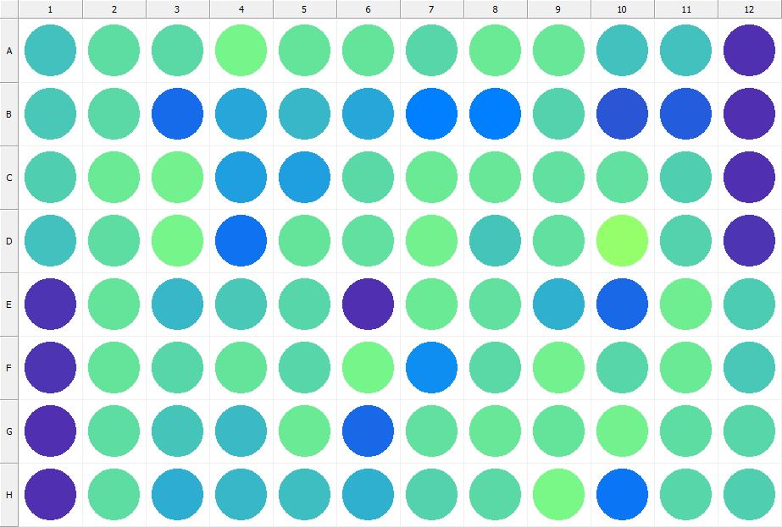

|  |
| --- |
| **Results for Tim_CTB(1) - channel 1 (RFU)** |

|  |  |  |  |  |  |  |  |  |  |  |  |  |
| --- | --- | --- | --- | --- | --- | --- | --- | --- | --- | --- | --- | --- |
|  | 01 | 02 | 03 | 04 | 05 | 06 | 07 | 08 | 09 | 10 | 11 | 12 |
| A | 129385 | 148981 | 146406 | 165246 | 153359 | 153022 | 144342 | 157838 | 155709 | 130946 | 129552 | 32832 |
| B | 133860 | 145305 | 70753 | 111116 | 123217 | 112354 | 85709 | 85362 | 141138 | 58014 | 63428 | 32606 |
| C | 139297 | 158001 | 162441 | 107549 | 107695 | 145115 | 157992 | 154585 | 149682 | 151504 | 138713 | 32768 |
| D | 129054 | 148788 | 164036 | 77674 | 153174 | 149663 | 162086 | 132449 | 150797 | 186697 | 141622 | 35269 |
| E | 34246 | 153149 | 121815 | 134803 | 143828 | 32367 | 156764 | 149845 | 117962 | 68748 | 160928 | 137523 |
| F | 34395 | 152324 | 144173 | 153329 | 144012 | 164764 | 94482 | 146468 | 163414 | 143186 | 158264 | 135660 |
| G | 32678 | 148133 | 132560 | 126377 | 157919 | 68618 | 151878 | 156538 | 152472 | 163066 | 149414 | 144654 |
| H | 33606 | 148433 | 116560 | 123282 | 127758 | 118555 | 141212 | 145190 | 167837 | 78761 | 143609 | 139425 |

|  |  |
| --- | --- |
| **Plate information** | |
|  | |
| **Plate** | 15 |
| **Repeat** | 1 |
| **Barcode** |  |
| **Measured height** | 14.78 |
| **Inside temperature at start** | 23.34 |
| **Inside temperature at end** | 23.34 |
| **Humidity at start** | 26.6 |
| **Humidity at end** | 26.6 |
| **Ambient temperature at start** | 22.95 |
| **Ambient temperature at end** | 22.95 |
| **Group** | 1 |
| **Label** | Tim_CTB(1) |
| **ScanX** | 0 |
| **ScanY** | 0 |
| **Measinfo** | De=1st Ex=Top Em=Top Wdw=N/A (14) |
| **Kinetics** | 0 |
| **Measurement date** | 12/12/2022 2:30:43 PM |
|  | |

|  |
| --- |
| **Background information** |
| Legend:  HDR1 - Plate  HDR2 - Label  HDR3 - Result  HDR4 - Signal  HDR5 - Flashes/Time  HDR6 - Meastime  HDR7 - MeasInfo |
| HDR1 HDR2 HDR3 HDR4 HDR5 HDR6 HDR7  15 Tim_CTB 0 1136 1 00:00:00.000 De=1st Ex=Top Em=Top Wdw=N/A (14) |
|  |

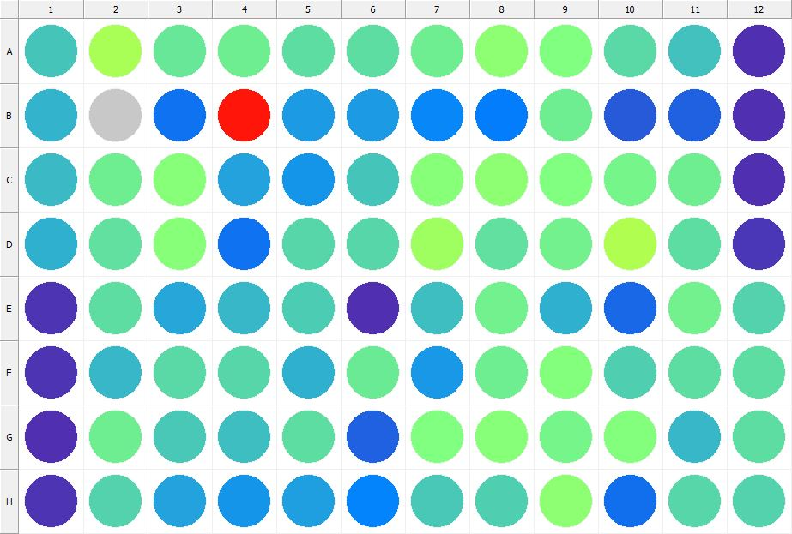

|  |
| --- |
| **Results for Tim_CTB(1) - channel 1 (RFU)** |

|  |  |  |  |  |  |  |  |  |  |  |  |  |
| --- | --- | --- | --- | --- | --- | --- | --- | --- | --- | --- | --- | --- |
|  | 01 | 02 | 03 | 04 | 05 | 06 | 07 | 08 | 09 | 10 | 11 | 12 |
| A | 133324 | 200479 | 155916 | 160195 | 147373 | 147470 | 159201 | 181778 | 170629 | 146934 | 129035 | 32861 |
| B | 120152 | 420383 | 76325 | 415034 | 104292 | 105106 | 89578 | 82699 | 161010 | 59603 | 64665 | 32570 |
| C | 124304 | 159898 | 176352 | 109940 | 98964 | 133072 | 177175 | 180231 | 171133 | 165822 | 160049 | 32401 |
| D | 118379 | 150429 | 177341 | 75574 | 144490 | 143047 | 191415 | 149665 | 162825 | 205171 | 148333 | 36289 |
| E | 34525 | 148168 | 111665 | 122639 | 137808 | 32086 | 128019 | 163169 | 117938 | 69902 | 162864 | 142401 |
| F | 33885 | 123089 | 145474 | 143802 | 119427 | 158822 | 102980 | 160010 | 174662 | 139292 | 149569 | 147840 |
| G | 33228 | 160257 | 134270 | 128123 | 147718 | 65348 | 172519 | 176023 | 165335 | 173390 | 122368 | 149500 |
| H | 35744 | 140783 | 109142 | 99186 | 105761 | 88052 | 135254 | 138053 | 179793 | 73197 | 143304 | 140699 |

|  |  |
| --- | --- |
| **Plate information** | |
|  | |
| **Plate** | 16 |
| **Repeat** | 1 |
| **Barcode** |  |
| **Measured height** | 14.78 |
| **Inside temperature at start** | 23.34 |
| **Inside temperature at end** | 23.34 |
| **Humidity at start** | 26.4 |
| **Humidity at end** | 26.2 |
| **Ambient temperature at start** | 23.05 |
| **Ambient temperature at end** | 23.15 |
| **Group** | 1 |
| **Label** | Tim_CTB(1) |
| **ScanX** | 0 |
| **ScanY** | 0 |
| **Measinfo** | De=1st Ex=Top Em=Top Wdw=N/A (14) |
| **Kinetics** | 0 |
| **Measurement date** | 12/12/2022 2:31:24 PM |
|  | |

|  |
| --- |
| **Background information** |
| Legend:  HDR1 - Plate  HDR2 - Label  HDR3 - Result  HDR4 - Signal  HDR5 - Flashes/Time  HDR6 - Meastime  HDR7 - MeasInfo |
| HDR1 HDR2 HDR3 HDR4 HDR5 HDR6 HDR7  16 Tim_CTB 0 1023 1 00:00:00.000 De=1st Ex=Top Em=Top Wdw=N/A (14) |
|  |

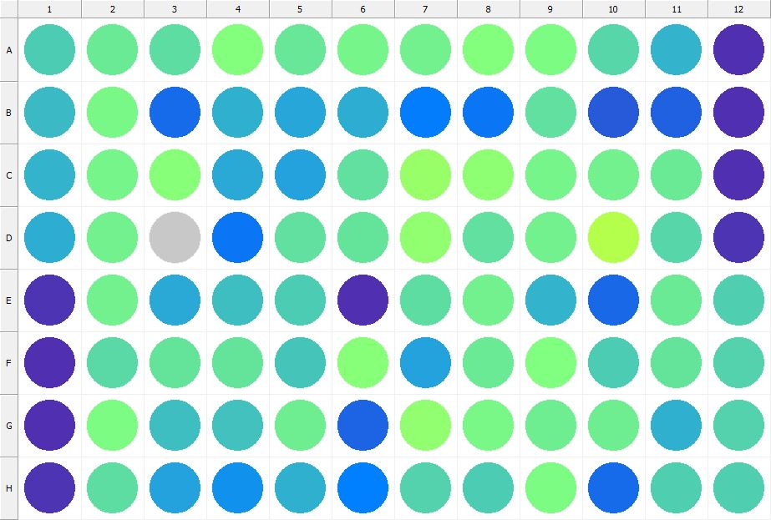

|  |
| --- |
| **Results for Tim_CTB(1) - channel 1 (RFU)** |

|  |  |  |  |  |  |  |  |  |  |  |  |  |
| --- | --- | --- | --- | --- | --- | --- | --- | --- | --- | --- | --- | --- |
|  | 01 | 02 | 03 | 04 | 05 | 06 | 07 | 08 | 09 | 10 | 11 | 12 |
| A | 137365 | 156975 | 149149 | 174120 | 156141 | 164581 | 162007 | 173971 | 169369 | 142873 | 120465 | 31602 |
| B | 125920 | 166342 | 72162 | 117871 | 110407 | 115194 | 83968 | 79052 | 151815 | 61181 | 65752 | 31755 |
| C | 120685 | 165534 | 175152 | 113073 | 110029 | 150448 | 188319 | 181729 | 163619 | 161226 | 157505 | 31477 |
| D | 115668 | 162613 | 426669 | 78486 | 150077 | 152578 | 183272 | 150826 | 161504 | 207144 | 144162 | 34995 |
| E | 33979 | 162873 | 113131 | 128339 | 136252 | 31724 | 147452 | 163175 | 121757 | 69174 | 158369 | 138108 |
| F | 33279 | 145030 | 153551 | 154167 | 132408 | 175522 | 109857 | 157472 | 170814 | 137430 | 152765 | 142231 |
| G | 33155 | 170481 | 127733 | 130364 | 159154 | 66445 | 183275 | 166588 | 160037 | 161055 | 119127 | 140523 |
| H | 33697 | 149527 | 108103 | 96876 | 117602 | 86918 | 140346 | 137913 | 168785 | 72869 | 138596 | 139694 |

|  |  |
| --- | --- |
| **Plate information** | |
|  | |
| **Plate** | 17 |
| **Repeat** | 1 |
| **Barcode** |  |
| **Measured height** | 14.78 |
| **Inside temperature at start** | 23.34 |
| **Inside temperature at end** | 23.46 |
| **Humidity at start** | 26.1 |
| **Humidity at end** | 26.2 |
| **Ambient temperature at start** | 23.15 |
| **Ambient temperature at end** | 23.17 |
| **Group** | 1 |
| **Label** | Tim_CTB(1) |
| **ScanX** | 0 |
| **ScanY** | 0 |
| **Measinfo** | De=1st Ex=Top Em=Top Wdw=N/A (14) |
| **Kinetics** | 0 |
| **Measurement date** | 12/12/2022 2:32:05 PM |
|  | |

|  |
| --- |
| **Background information** |
| Legend:  HDR1 - Plate  HDR2 - Label  HDR3 - Result  HDR4 - Signal  HDR5 - Flashes/Time  HDR6 - Meastime  HDR7 - MeasInfo |
| HDR1 HDR2 HDR3 HDR4 HDR5 HDR6 HDR7  17 Tim_CTB 0 1087 1 00:00:00.000 De=1st Ex=Top Em=Top Wdw=N/A (14) |
|  |

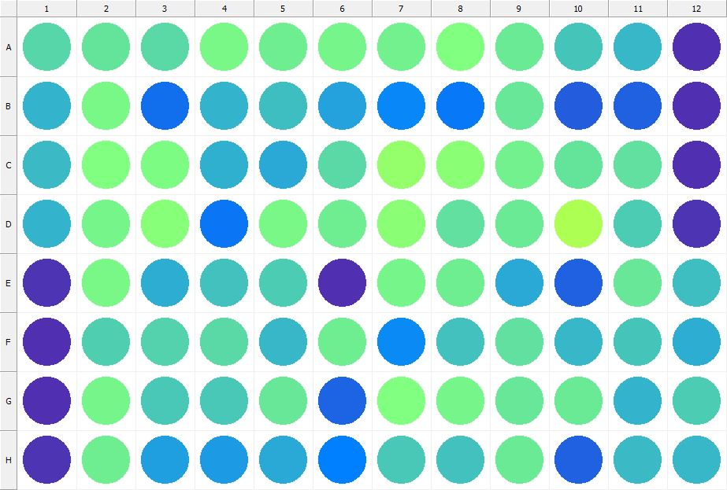

|  |
| --- |
| **Results for Tim_CTB(1) - channel 1 (RFU)** |

|  |  |  |  |  |  |  |  |  |  |  |  |  |
| --- | --- | --- | --- | --- | --- | --- | --- | --- | --- | --- | --- | --- |
|  | 01 | 02 | 03 | 04 | 05 | 06 | 07 | 08 | 09 | 10 | 11 | 12 |
| A | 143999 | 152348 | 145789 | 167859 | 160227 | 164230 | 161656 | 171797 | 158188 | 132036 | 123767 | 31335 |
| B | 121078 | 167948 | 75013 | 119635 | 127896 | 109082 | 91107 | 81903 | 155971 | 63184 | 64921 | 32562 |
| C | 124976 | 172643 | 169898 | 117897 | 113276 | 145347 | 184807 | 177451 | 161559 | 154137 | 150010 | 32785 |
| D | 119847 | 165009 | 176012 | 79917 | 167073 | 159361 | 179324 | 151676 | 158833 | 202330 | 137540 | 35638 |
| E | 34271 | 165890 | 116159 | 130114 | 135694 | 31828 | 164722 | 160048 | 114411 | 65060 | 154884 | 127794 |
| F | 32425 | 139394 | 142045 | 145709 | 123987 | 160013 | 93867 | 130591 | 151767 | 121845 | 131637 | 115086 |
| G | 33176 | 163651 | 133788 | 133948 | 155247 | 67554 | 172111 | 163568 | 154399 | 157468 | 119568 | 137620 |
| H | 34950 | 159390 | 106424 | 104906 | 113795 | 85464 | 134719 | 130298 | 156871 | 64343 | 124377 | 122134 |

|  |  |
| --- | --- |
| **Plate information** | |
|  | |
| **Plate** | 18 |
| **Repeat** | 1 |
| **Barcode** |  |
| **Measured height** | 14.78 |
| **Inside temperature at start** | 23.44 |
| **Inside temperature at end** | 23.44 |
| **Humidity at start** | 26.2 |
| **Humidity at end** | 26.4 |
| **Ambient temperature at start** | 22.86 |
| **Ambient temperature at end** | 22.95 |
| **Group** | 1 |
| **Label** | Tim_CTB(1) |
| **ScanX** | 0 |
| **ScanY** | 0 |
| **Measinfo** | De=1st Ex=Top Em=Top Wdw=N/A (14) |
| **Kinetics** | 0 |
| **Measurement date** | 12/12/2022 2:32:45 PM |
|  | |

|  |
| --- |
| **Background information** |
| Legend:  HDR1 - Plate  HDR2 - Label  HDR3 - Result  HDR4 - Signal  HDR5 - Flashes/Time  HDR6 - Meastime  HDR7 - MeasInfo |
| HDR1 HDR2 HDR3 HDR4 HDR5 HDR6 HDR7  18 Tim_CTB 0 1035 1 00:00:00.000 De=1st Ex=Top Em=Top Wdw=N/A (14) |
|  |

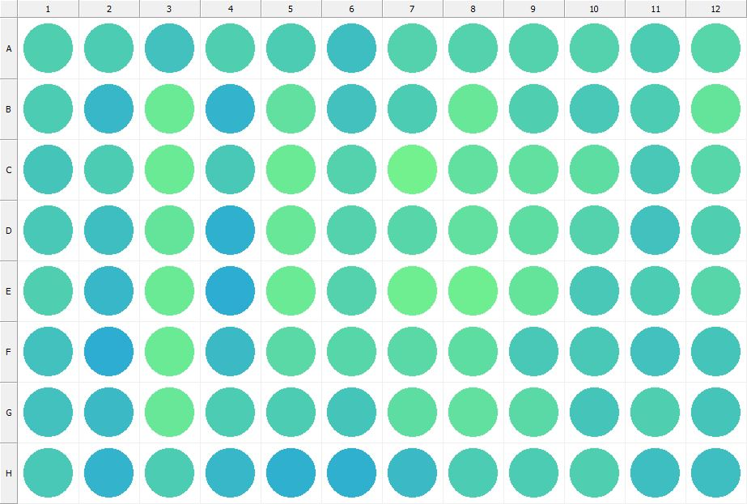

|  |
| --- |
| **Results for Tim_CTB(1) - channel 1 (RFU)** |

|  |  |  |  |  |  |  |  |  |  |  |  |  |
| --- | --- | --- | --- | --- | --- | --- | --- | --- | --- | --- | --- | --- |
|  | 01 | 02 | 03 | 04 | 05 | 06 | 07 | 08 | 09 | 10 | 11 | 12 |
| A | 139125 | 135886 | 130184 | 140309 | 136348 | 126718 | 141779 | 142488 | 142638 | 141571 | 137215 | 143724 |
| B | 136042 | 123454 | 158034 | 120530 | 149828 | 129476 | 137312 | 154401 | 139957 | 134200 | 135897 | 153235 |
| C | 133202 | 136318 | 156905 | 135136 | 158620 | 141994 | 162247 | 150669 | 151578 | 148980 | 135364 | 144606 |
| D | 134372 | 127081 | 153572 | 119155 | 155933 | 141222 | 144476 | 150135 | 148057 | 140697 | 131019 | 139053 |
| E | 138835 | 123427 | 156817 | 115528 | 157091 | 141142 | 160935 | 160673 | 153362 | 134848 | 136239 | 143008 |
| F | 129259 | 114974 | 156853 | 126098 | 147037 | 143087 | 145730 | 149299 | 135095 | 134606 | 130098 | 131265 |
| G | 130524 | 124594 | 154604 | 136444 | 135958 | 132546 | 149151 | 151530 | 147254 | 132510 | 138730 | 133186 |
| H | 133630 | 120126 | 136875 | 122942 | 118284 | 119000 | 125760 | 136481 | 135937 | 138552 | 128546 | 128176 |

|  |  |
| --- | --- |
| **Plate information** | |
|  | |
| **Plate** | 19 |
| **Repeat** | 1 |
| **Barcode** |  |
| **Measured height** | 14.78 |
| **Inside temperature at start** | 23.44 |
| **Inside temperature at end** | 23.44 |
| **Humidity at start** | 26.2 |
| **Humidity at end** | 26.2 |
| **Ambient temperature at start** | 23.05 |
| **Ambient temperature at end** | 23.05 |
| **Group** | 1 |
| **Label** | Tim_CTB(1) |
| **ScanX** | 0 |
| **ScanY** | 0 |
| **Measinfo** | De=1st Ex=Top Em=Top Wdw=N/A (14) |
| **Kinetics** | 0 |
| **Measurement date** | 12/12/2022 2:33:25 PM |
|  | |

|  |
| --- |
| **Background information** |
| Legend:  HDR1 - Plate  HDR2 - Label  HDR3 - Result  HDR4 - Signal  HDR5 - Flashes/Time  HDR6 - Meastime  HDR7 - MeasInfo |
| HDR1 HDR2 HDR3 HDR4 HDR5 HDR6 HDR7  19 Tim_CTB 0 1001 1 00:00:00.000 De=1st Ex=Top Em=Top Wdw=N/A (14) |
|  |

|  |  |
| --- | --- |
|  | |
| **Basic assay information** | |
| **Assay ID** | 24280 |
| **Assay Started** | 12/12/2022 2:18:45 PM |
| **Assay Finished** | 12/12/2022 2:33:43 PM |
| **Assay Exported** | 12/12/2022 3:37:05 PM |
| **Protocol ID** | 100568 |
| **Protocol Name** | Copy of 96well-CTB_Tim |
| **Serial#** | 1020141 |
|  | |
|  | |
|  | |
| **Protocol information** | |
| **Protocol:** | |
| **Protocol name** | Copy of 96well-CTB_Tim |
| **Number of assay repeats** | 1 |
| **Start assay repeat each** | N/A |
| **Number of plate repeats** | 1 |
| **Start plate repeat each** | N/A |
| **Is label meas. height used** | Yes |
| **Height of measurement** | Defined in label |
| **Is gripper height used** | No |
| **Mode of measurement** | By Rows, bi-directional |
| **Rotated plate** | No |
| **Soft move** | No |
| **Protocol notes** |  |
|  | |
| **Plate type:** | |
| **Name of the plate type** | 96 General |
| **Number of rows** | 8 |
| **Number of columns** | 12 |
| **Number of the wells in the plate** | 96 |
| **Height of the plate** | 14.35 mm |
|  | |
| **Coordinates of corners:** | |
| **96 General + Tim_CTB** | |
| 14.38 mm x------------------------------------------------------ x 113.38 mm  11.24 mm 11.24 mm | |
| 14.38 mm x------------------------------------------------------ x 113.38 mm  74.24 mm 74.24 mm | |
|  | |
|  | |

|  |  |
| --- | --- |
| **Platemap:** | |
| **Plate** | 1 |
| **Group** | 1 |
|  | |

|  |  |  |  |  |  |  |  |  |  |  |  |  |
| --- | --- | --- | --- | --- | --- | --- | --- | --- | --- | --- | --- | --- |
|  | **01** | **02** | **03** | **04** | **05** | **06** | **07** | **08** | **09** | **10** | **11** | **12** |
| **A** | - | - | - | - | - | - | - | - | - | - | - | - |
| **B** | - | - | - | - | - | - | - | - | - | - | - | - |
| **C** | - | - | - | - | - | - | - | - | - | - | - | - |
| **D** | - | - | - | - | - | - | - | - | - | - | - | - |
| **E** | - | - | - | - | - | - | - | - | - | - | - | - |
| **F** | - | - | - | - | - | - | - | - | - | - | - | - |
| **G** | - | - | - | - | - | - | - | - | - | - | - | - |
| **H** | - | - | - | - | - | - | - | - | - | - | - | - |

|  |  |
| --- | --- |
|  | |
| **-** | Undefined |
|  | |
|  | |

|  |  |
| --- | --- |
| **Calculations:** | |
| **No calculations.** | |
|  | |
| **Auto export parameters:** | |
| **Export format** | Plate2 |
| **Include basic assay information** | Yes |
| **Place assay information at** | End of file |
| **Include basic plate information** | Yes |
| **Place plate information at** | Beginning of plate |
| **Include protocol information** | Yes |
| **Protocol info level** | Large |
| **Include error and warning information** | Yes |
| **Include background information** | Yes |
| **Add plate number to the file name** | Yes |
| **Each plate to separate file** | No |
| **Field separator to use** | System |
| **File name format** | <DefaultDataFolder>\<Date>\<ProtocolName>_<AssayID>.csv |
|  | |
| **Operations:** | |
| Plate 1  Group 1  Measurement  Label..................................................... Tim_CTB(1) | |
| **Labels:** | |
| **Tim_CTB** | 4000137 |
| **Top mirror** | General |
| **Bottom mirror** | N/A |
| **Exc. filter** | Photometric 530 |
| **Using of excitation filter** | Top |
| **2nd exc. filter** | N/A |
| **Using of 2nd excitation filter** | Top |
| **Ems. filter** | Photometric 590 |
| **2nd ems. filter** | N/A |
| **Measurement height** | 6.5 mm |
| **Number of flashes** | 1 |
| **Number of flashes integrated** | 1 |
| **PMT gain** | 1 |
| **Excitation light** | 100% |
| **Reference excitation light** | 100% |
| **Emission light** | 100% |
| **Reference AD gain** | 4 |
| **Reference signal** | 383728 |
| **Last edited** | 2/11/2019 10:20:00 AM |
| **Last edited by** | EnVision |
| **Factory preset** | No |
|  | |
| **Filters:** | |
| **Photometric 530** | 310 |
| **Filter type** | Excitation |
| **Description** | P530 CWL=530nm BW=8nm Tmin=55% |
| **Used with** | Absorbance,DELFIA - Time-resolved Fluorescence,Fluorescence Intensity,Fluorescence Polarization,LANCE - Time-resolved Fluorescence |
| **Last edited** | 8/19/2014 4:24:21 PM |
| **Last edited by** | Installation |
| **Factory preset** | Yes |
|  | |
| **Photometric 590** | 314 |
| **Filter type** | Excitation |
| **Description** | P590 CWL=590nm BW=8nm Tmin=40% |
| **Used with** | Absorbance,DELFIA - Time-resolved Fluorescence,Fluorescence Intensity,Fluorescence Polarization,LANCE - Time-resolved FluorescenceAbsorbance,DELFIA - Time-resolved Fluorescence,Fluorescence Intensity,Fluorescence Polarization,LANCE - Time-resolved Fluorescence |
| **Last edited** | 8/19/2014 4:24:21 PM |
| **Last edited by** | Installation |
| **Factory preset** | Yes |
|  | |
| **Mirror modules:** | |
| **General** | 401 |
| **Used by** | Top |
| **Dual** | No |
| **Bias** | No |
| **Description** | BS50 |
| **Used with** | Luminescence,DELFIA - Time-resolved Fluorescence,Fluorescence Intensity,Fluorescence Polarization,LANCE - Time-resolved Fluorescence |
| **Last edited** | 8/19/2014 4:24:21 PM |
| **Last edited by** | Installation |
| **Factory preset** | Yes |
|  | |
| **Instrument:** | |
| **Serial number** | 1020141 |
| **Nickname** | EnVision |
|  | |
|  | |
|  | |
|  | |
| **Notifications:** | |
| Assay notifications:  INFO: Assay aborted at plate 19 plate repeat 1 and well H01. There may be missing results | |
| Notifications for plate 4 repeat 1:  WARNING: Some of the results may be invalid due to saturation of electronics. To fix the problem try to limit the excitation light or decrease the detector gain using the label editor.  In a case of label using Fluorescence Monochromator you can also try to use less flashes lower excitation wavelength or higher emission wavelength. | |
| WARNING: Measured signal is saturated in the following wells: D06 | |
| Notifications for plate 12 repeat 1:  WARNING: Some of the results may be invalid due to saturation of electronics. To fix the problem try to limit the excitation light or decrease the detector gain using the label editor.  In a case of label using Fluorescence Monochromator you can also try to use less flashes lower excitation wavelength or higher emission wavelength. | |
| WARNING: Measured signal is saturated in the following wells: C02 C06 | |
| Notifications for plate 14 repeat 1:  WARNING: Some of the results may be invalid due to saturation of electronics. To fix the problem try to limit the excitation light or decrease the detector gain using the label editor.  In a case of label using Fluorescence Monochromator you can also try to use less flashes lower excitation wavelength or higher emission wavelength. | |
| WARNING: Measured signal is saturated in the following wells: C09 E11 F08 | |
| Notifications for plate 16 repeat 1:  WARNING: Some of the results may be invalid due to saturation of electronics. To fix the problem try to limit the excitation light or decrease the detector gain using the label editor.  In a case of label using Fluorescence Monochromator you can also try to use less flashes lower excitation wavelength or higher emission wavelength. | |
| WARNING: Measured signal is saturated in the following wells: B02 | |
| Notifications for plate 17 repeat 1:  WARNING: Some of the results may be invalid due to saturation of electronics. To fix the problem try to limit the excitation light or decrease the detector gain using the label editor.  In a case of label using Fluorescence Monochromator you can also try to use less flashes lower excitation wavelength or higher emission wavelength. | |
| WARNING: Measured signal is saturated in the following wells: D03 | |
|  | |
|  | |

|  |
| --- |
|  |
| **Exported with EnVision Workstation version 1.13.3009.1409** |